Programming Essentials 2024

Assignment 3

Due: 26 February 2024 14:00

Muhammad Huzaifa Ali Khan Student no. 72746

All files are in the following repository:

Using: git clone https://github.com/bjrochem72/prog_ess

1. Using the following code snippet and the file Assign3Q1.java, use a switch statement to determine if the variable someChar is a vowel or consonant in the English language alphabet.

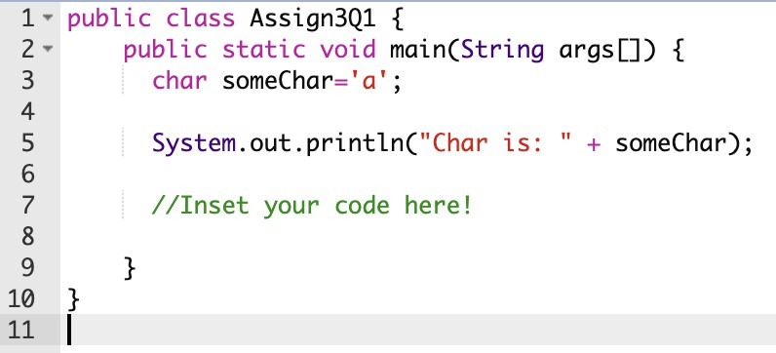

Solution:

public class Assign3Q1 {

public static void main(String args[]) {

char someChar = 'a';

System.out.println("Char is: " + someChar);

// Using a switch statement to determine if someChar is a vowel or consonant

switch (someChar) {

case 'a':

case 'e':

case 'i':

case 'o':

case 'u':

System.out.println("It's a vowel.");

break;

default:

System.out.println("It's a consonant.");

}

}

}

1. Using the following code snippet and the file Assign3Q2.java, use a switch statement to print out the number of days in the month stored in the variable currentMonth.

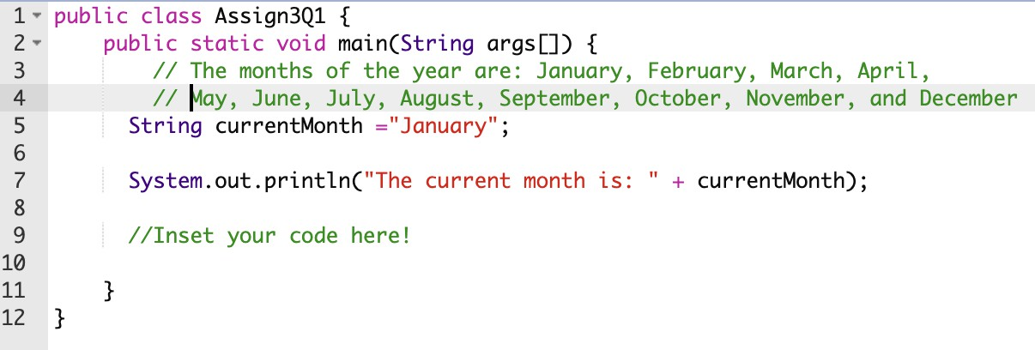

Solution:

public class Assign301 {

public static void main(String args[]) {

// The months of the year are: January, February, March, April,

// May, June, July, August, September, October, November, and December

String currentMonth = "January";

System.out.println("The current month is: " + currentMonth);

// Using a switch statement to print out the number of days in the month

switch (currentMonth) {

case "January":

case "March":

case "May":

case "July":

case "August":

case "October":

case "December":

System.out.println("Number of days: 31");

break;

case "April":

case "June":

case "September":

case "November":

System.out.println("Number of days: 30");

break;

case "February":

System.out.println("Number of days: 28 or 29 (leap year)");

break;

default:

System.out.println("Invalid month");

}

}

}

1. Using the following code snippet and the file Assign3Q3.java, use a for loop to calculate the factorial of the integer stored in the variable currentValue. The factorial of a number is explained here

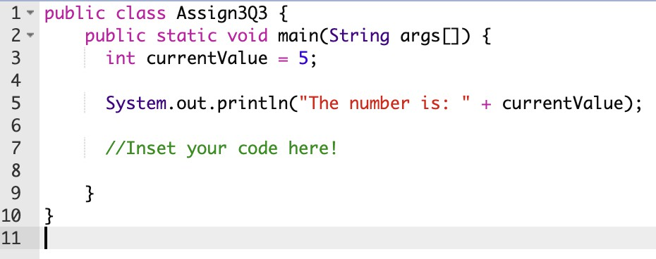

Solution:

public class Assign303 {

public static void main(String args[]) {

int currentValue = 5;

System.out.println("The number is: " + currentValue);

long factorial = 1;

for (int i = 1; i <= currentValue; i++) {

factorial *= i;

}

System.out.println("The factorial of " + currentValue + " is: " + factorial);

}

}

1. Using the following code snippet and the file Assign3Q4.java, use a for loop to draw the following shapes to the screen omitting the i), ii), iii) etc.

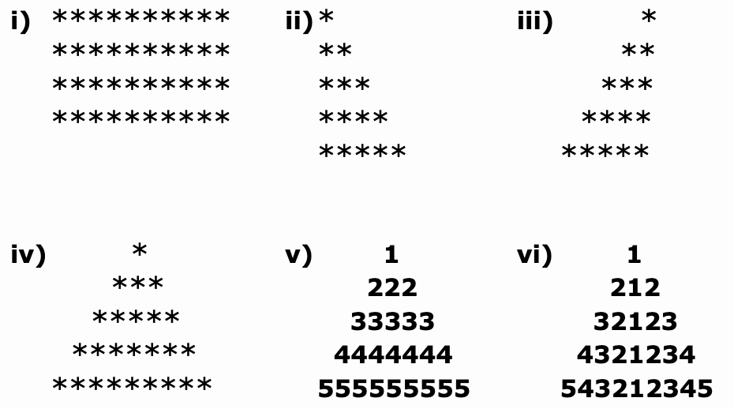

Solution:

(i)

for (int i = 0; i < 3; i++) {

for (int j = 0; j < 20; j++) {

System.out.print("*");

}

System.out.println();

}

(ii)

for (int i = 1; i <= 5; i++) {

for (int j = 0; j < i; j++) {

System.out.print("*");

}

System.out.println();

}

(iii)

for (int i = 0; i < 4; i++) {

for (int j = 0; j < 4 - i; j++) {

System.out.print(" ");

}

for (int k = 0; k <= i; k++) {

System.out.print("*");

}

System.out.println();

}

(iv)

for (int i = 0; i < 4; i++) {

for (int j = 0; j < i; j++) {

System.out.print(" ");

}

for (int k = 0; k < 4 - i; k++) {

System.out.print("*");

}

System.out.println();

}

(v)

for (int i = 1; i <= 5; i++) {

for (int j = 0; j < 5 - i; j++) {

System.out.print(" ");

}

for (int k = 1; k <= 2 * i - 1; k++) {

System.out.print(i);

}

System.out.println();

}

(vi)

for (int i = 1; i <= 5; i++) {

for (int j = 0; j < 5 - i; j++) {

System.out.print(" ");

}

for (int k = i; k >= 1; k--) {

System.out.print(k);

}

for (int l = 2; l <= i; l++) {

System.out.print(l);

}

System.out.println();

}

}

}

1. Using the file Assign3Q5.java, repeat question (3) using a while loop.

public class Assign3Q5 {

public static void main(String args[]) {

int currentValue = 5;

System.out.println("The number is: " + currentValue);

// Using a while loop to calculate the factorial

long factorial = 1;

int i = 1;

while (i <= currentValue) {

factorial *= i;

i++;

}

System.out.println("The factorial of " + currentValue + " is: " + factorial);

}

}

1. Using the file Assign3Q6.java, repeat question (4) using a do while loop.

public class Assign3Q6 {

public static void main(String args[]) {

int i = 0;

(i)

do {

int j = 0;

do {

System.out.print("*");

j++;

} while (j < 20);

System.out.println();

i++;

} while (i < 3);

i = 1;

(ii)

do {

int j = 0;

do {

System.out.print("*");

j++;

} while (j < i);

System.out.println();

i++;

} while (i <= 5);

i = 0;

(iii)

do {

int j = 0;

do {

System.out.print(" ");

j++;

} while (j < 4 - i);

int k = 0;

do {

System.out.print("*");

k++;

} while (k <= i);

System.out.println();

i++;

} while (i < 4);

i = 0;

(iv)

do {

int j = 0;

do {

System.out.print(" ");

j++;

} while (j < i);

int k = 0;

do {

System.out.print("*");

k++;

} while (k < 4 - i);

System.out.println();

i++;

} while (i < 4);

i = 1;

(v)

do {

int j = 0;

do {

System.out.print(" ");

j++;

} while (j < 5 - i);

int k = 0;

do {

System.out.print(i);

k++;

} while (k < 2 * i - 1);

System.out.println();

i++;

} while (i <= 5);

i = 1;

(vi)